[**Multitasking, Multithreading and Multiprocessing**](https://www.geeksforgeeks.org/difference-between-multitasking-multithreading-and-multiprocessing/) **(Important)**

[**Difference between Multiprogramming and Multitasking**](https://www.geeksforgeeks.org/difference-between-multiprogramming-and-multitasking/?ref=rp) **(Important)**

[**Difference between Multiprocessing and Multithreading**](https://www.geeksforgeeks.org/difference-between-multiprocessing-and-multithreading/?ref=rp) **(Important)**

**CPU Scheduling: -**

* [**Process**](https://www.geeksforgeeks.org/introduction-of-process-management/)
* [**Context Switch**](https://www.youtube.com/watch?v=vTgccrbYHYs&list=PLBlnK6fEyqRiVhbXDGLXDk_OQAeuVcp2O&index=20)
* [**Process Schedulers**](https://www.geeksforgeeks.org/process-schedulers-in-operating-system/)
* [**CPU Scheduling**](https://www.geeksforgeeks.org/cpu-scheduling-in-operating-systems/)
* [**CPU Scheduling Algorithms**](https://www.geeksforgeeks.org/cpu-scheduling-in-operating-systems/)
  + [**FCFS CPU Scheduling**](https://www.geeksforgeeks.org/program-for-fcfs-cpu-scheduling-set-1/)
  + [**Convoy Effect**](https://www.geeksforgeeks.org/convoy-effect-operating-systems/)
  + [**Shortest Job First (or SJF) CPU Scheduling**](https://www.geeksforgeeks.org/program-for-shortest-job-first-or-sjf-cpu-scheduling-set-1-non-preemptive/)
  + **Longest Job First (reverse SJF)**
  + [**Shortest Remaining Time First scheduling Preemptive**](https://www.geeksforgeeks.org/program-for-shortest-job-first-sjf-scheduling-set-2-preemptive/)
  + [**Longest Remaining Time First Preemptive**](https://www.geeksforgeeks.org/longest-remaining-time-first-lrtf-cpu-scheduling-algorithm/)
  + [**Round Robin scheduling**](https://www.geeksforgeeks.org/program-round-robin-scheduling-set-1/)
  + [**Priority CPU Scheduling**](https://www.geeksforgeeks.org/priority-cpu-scheduling-with-different-arrival-time-set-2/)
  + [**Multilevel Queue (MLQ) CPU Scheduling**](https://www.geeksforgeeks.org/multilevel-queue-mlq-cpu-scheduling/)
  + [**Multilevel Feedback Queue Scheduling (MLFQ) CPU Scheduling**](https://www.geeksforgeeks.org/multilevel-feedback-queue-scheduling-mlfq-cpu-scheduling/)
* [**Process Synchronization set 1**](https://prepinsta.com/operating-systems/process-synchronization/)
  + **(peterson solution, race condition, critical setion, CS solution, Semaphores)**
* [**Process Synchronization set 2**](https://www.geeksforgeeks.org/process-synchronization-set-2/?ref=rp)

[**Inter-process Communication**](https://www.youtube.com/watch?v=dJuYKfR8vec&list=PLBlnK6fEyqRiVhbXDGLXDk_OQAeuVcp2O&index=23)

[**Mutex and difference between Mutex and Semaphores**](https://prepinsta.com/operating-systems/mutex/) **(Important)**

[**Thread in Operating System**](https://www.geeksforgeeks.org/thread-in-operating-system/) **(Important)**

[**Multithreading in Operating System**](https://www.geeksforgeeks.org/multithreading-in-operating-system/?ref=rp) **(Important)**

[**Benefits of Multithreading in Operating System**](https://www.geeksforgeeks.org/benefits-of-multithreading-in-operating-system/?ref=rp) **(Important)**

**Operating System**

1. An operating system is a system software that controls the execution of application programs and acts as an interface between the user of a computer and the computer hardware.
2. Purpose or function of an operating system is
   1. Provide an environment in which a user can execute programs efficiently.
   2. Resource Management: - I/O management, Memory Management, Process management.
3. Goals of Operating System: -
   1. Providing convenience
   2. Efficiency
4. Examples: - Windows 10, [Apple's mac OS](https://www.lifewire.com/what-is-macos-4144656), Ubuntu, Android etc.

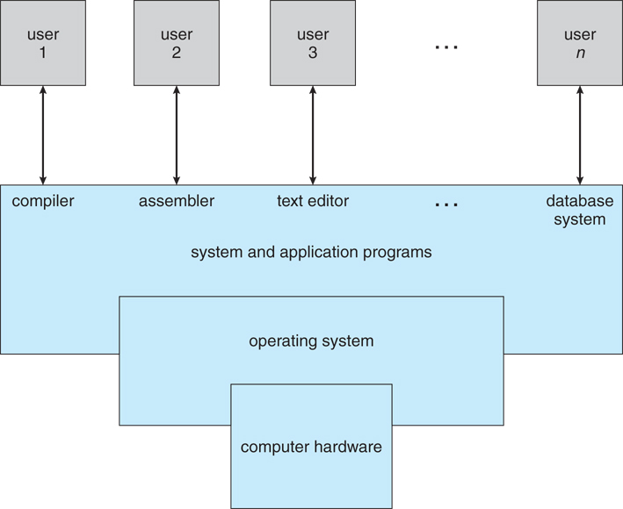

**Types of OS and their advantage and disadvantage**

* Batch OS
* Time Sharing OS
* Distributed OS
* Network OS
* Real Time OS
* [Multi Programming](https://www.youtube.com/watch?v=OOLy8jnl1hA&list=PLmXKhU9FNesSFvj6gASuWmQd23Ul5omtD&index=5)
* [Multi-Tasking](https://www.youtube.com/watch?v=UcXWaeRikSo&list=PLmXKhU9FNesSFvj6gASuWmQd23Ul5omtD&index=6)
* [Multi-Processing](https://www.youtube.com/watch?v=xJ9yesCHLCI&list=PLmXKhU9FNesSFvj6gASuWmQd23Ul5omtD&index=7)

**Batch Systems**

* In this type of system, there is **no direct interaction between user and the computer.**
* The user has to submit a job to a computer operator.
* Then computer operator places a batch of several jobs on an input device.
* Jobs are batched together by type of languages and requirement.
* Then a special program, the monitor, manages the execution of each program in the batch.
* The monitor is always in the main memory and available for execution.

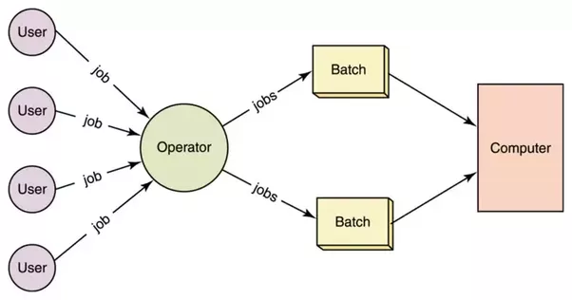

**Advantages of Simple Batch Systems**

1. No interaction between user and computer.
2. No mechanism to prioritize the processes.

**Multi-programming Batch Systems**

* In this the operating system picks up and begins to execute one of the jobs from memory.
* Once this job needs an I/O operation operating system switches to another job (CPU and OS always busy).
* Jobs in the memory are always less than the number of jobs on disk (Job Pool).
* If several jobs are ready to run at the same time, then the system chooses which one to run through the process of **CPU Scheduling**.
* In Non-Multiprogrammed system, there are moments when CPU sits idle and does not do any work.
* In Multiprogramming system, CPU will never be idle and keeps on processing.

**Time Sharing Systems** are very similar to Multiprogramming batch systems. In fact, time sharing systems are an extension of multiprogramming systems. In Time sharing systems the prime focus is on **minimizing the response time**, while in multiprogramming the prime focus is to maximize the CPU usage.

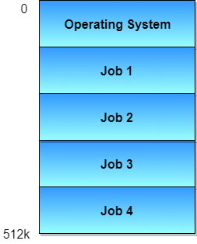

Multiprocessor Systems

A Multiprocessor system consists of several processors that share a common physical memory. Multiprocessor system provides higher computing power and speed. In multiprocessor system all processors operate under single operating system. Multiplicity of the processors and how they do act together are transparent to the others.

Advantages of Multiprocessor Systems

1. Enhanced performance
2. Execution of several tasks by different processors concurrently, increases the system's throughput without speeding up the execution of a single task.
3. If possible, system divides task into many subtasks and then these subtasks can be executed in parallel in different processors. Thereby speeding up the execution of single tasks.

**Components of a computer system**

1. The **hardware**- the central processing unit (CPU), the Memory and the I/O devices provides the basic computing resources for the system.
2. The **application programs** - such as word processors, spreadsheets, compilers, and Web browsers - define the ways in which these resources are used to solve user’s computing problems.
3. The **operating system** controls the hardware and coordinates its use among the various application programs for the various users



**What Operating System Do**

**The operating system is responsible for the following activities in connection with process management:**

* Scheduling processes and threads on the CPU
* Creating and deleting processes
* Suspending and resuming processes
* process synchronization
* process communication

**The operating system is responsible for the following activities in connection with memory management:**

* Keeping track of which parts of memory are currently being used and by whom
* Deciding which processes to move into and out of memory
* Allocating and deallocating memory space as needed

**The operating system is responsible for the following activities in connection with file management:**

* Creating and deleting files
* Creating and deleting directories to organize files
* Supporting primitives for manipulating files and directories
* Mapping files onto secondary storage
* Backing up files on stable (nonvolatile) storage media